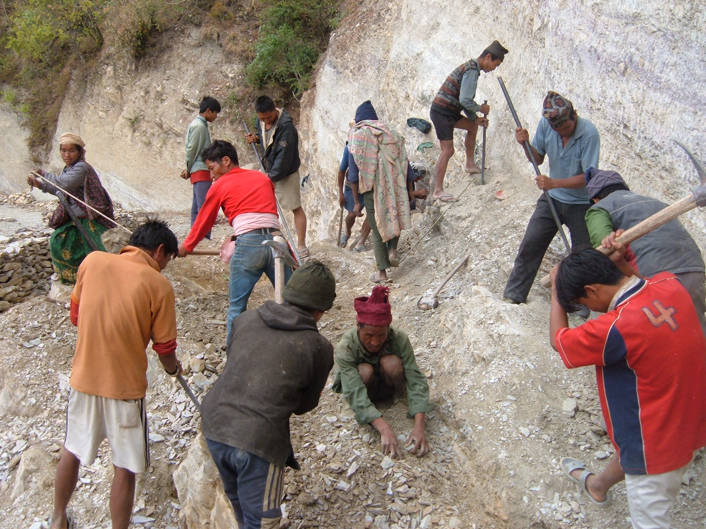
A work team on the Martyrs Road, Rolpa District.

