

WE’VE
SCORED

The NEF (New Economics Foundation) REPORT delivers a strong blow to Developer’s undeveloped plans
The New Economics Foundation report commissioned by Friends of Queen’s Market to look into the economic benefits of the market as it currently stands found that the market offers more to local people than any supermarket ever could.
Newham Council said the development would create 300 new jobs but the NEF research found Queen’s Market currently provides over 500 jobs to people. They are wanting to make more people jobless.
The NEF said the market currently allows for new businesses and local entrepreneurs which is vital for the local economy and any affect on it will spell danger.

ASDA IS KICKED OUT
OF QUEEN’S MARKET
This week, after over 3 years of pushing the campaign barrel, Asda/Wal-Mart finally decided to push off somewhere else, amid mounting national pressure against its plans to destroy 100 year old, much loved Queen’s Market in Upton Park.
WELL DONE EVERYONE!
Letters, emails, signature petitions and phone calls from people from across the world expressed their concern on this issue which is so important to local people in Upton Park.
The film Wal-Mart: The High Cost of Low Prices featuring Queen’s Market and it’s local traders was recommended in the Metro newspaper’s top five films to watch, describing the film as a “shocking revelation” of Wal-Mart’s practice and it policy towards it’s own staff.
Newham’s Mayor Sir Robbin’ Walmart-Wales has to admit his Asda idea was a rotten egg, but he has not as yet apologised. Wales should stop wasting public money on St. Modwen and listen to what we need for our local area. He’s even lost his entire Green Street West ward Councillors to RESPECT in recent local elections...
LONG LIVE QUEEN’S MARKET!

WHAT THIS REVEALS… THE COUNCIL’S POLICY TO PUT MULTI-NATIONALS BEFORE LOCAL NEEDS > LOCAL DEMOCRACY IS FAILING THE VOTER > HOW INEPT OUR COUNCIL IS WITH ITS PAID ADVISORS > RAISES SERIOUS QUESTIONS ON THE PUBLIC CONSULTATION PROCESS.

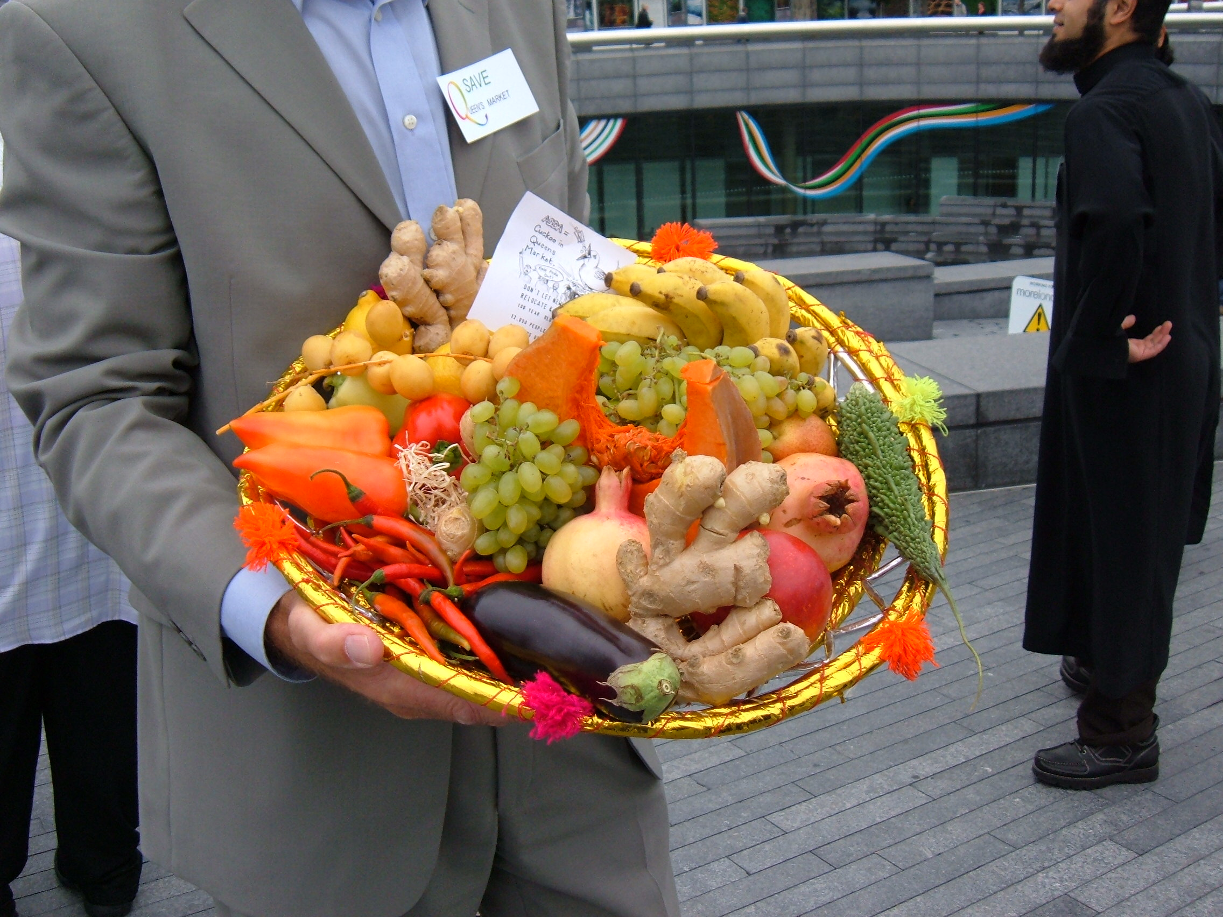

“Don’t be fooled by St. Modwen’s new mask in giving us a coffee-shop library and service centre (which both already exist in Green Street). Asda may have taken a back seat for now but be cautious of more disguises which hide more big deals at our expenses. Their forever changing “conceptual” plans will have many rough edges. WE WILL FIGHT ‘TIL THEY LEAVE

EAST END vs CULTURE VULTURES

Third-rate Developers From Hell, St. Modwen are still lurking behind the meat wagon waiting to pounce on the market, still wanting to “attract another major retailer to the project” (Council website). Market-in-malls and multi-national developments are being rejected by people across the country because they are at the expense of local trade and local shops. The clone-town nightmare has not ended yet and dead spaces continue to degrade communities. Our recent success of defeating the biggest corporation in the world will help other causes across the country.
St. Modwen’s track record on destroying markets like poor old Edmonton Market is extremely concerning because it’s this lack of experience and cultural insensitivity that fuels mistrust in people. Inexperienced developers who are dealing with family businesses and livelihoods in an area where they have no connection nor understanding……….……….. St. Modwen deserve an ASBO

Our website has already had 5,000 visitors. The world is listening and it’s an international issue.
Features include Evening Standard’s “Save Our Small Shops” campaign and Observer’s Food Supplement.
WWW.FRIENDSOFQUEENSMARKET.ORG.UK
DONATE FOR THE CAMPAIGN IN 2006

GET READY FOR THE SECOND HALF: DEFEATING BIG BROTHER’S LITTLE BROTHER-
ST. MODWEN

IN YOUR NEXT PUBLICATION

