What’s Wrong With UK Democracy?

The short answer to this question is that it’s disappearing and fast. For 35 years successive governments have been chipping away at our civil liberties, freedoms and democracy.
Since 1997, Neo-Labour has been taking a hydraulic drill to our way of life and have destroyed civil liberties cherished, some, for hundreds of years.

ATTACKS ON YOUR RIGHTS
Since 1994 Conservative and Neo-Labour Governments have been responsible for the following examples of systematic destruction of civil liberties and democracy; the list is endless:
- the right to freedom of expression splattered,
- the right to privacy and family life trampled on,
- the right to silence (designed to protect the innocent from incriminating themselves) destroyed,
- double jeopardy railroaded,
- right to peaceful protest scuppered,
- right to peaceful assembly scattered,
- trial by jury savaged,
- right to a fair trial attacked,
- right to freedom of movement halted,
- right to freedom of association ended,
- right to freedom from arbitrary arrest evaporated,
- right to presumption of innocence undermined,
- right to confidentiality of medical records stopped,
- suspects rights in custody taken apart,
- right to security of property eroded,
- right to privacy of communications disappeared.

“THE ENABLING ACT”

BLAIR GIVING HIS GOVERNMENT ABSOLUTE POWER
As if the above list wasn’t a comprehensive enough disaster for our civil liberties Tony Blair’s army of traitors enacted a bill that rivals Hitler’s Enabling Act 1933. The most serious threat to our democracy and freedoms comes via the Civil Contingencies Act 2004.
In the wrong hands (Blair’s?) it could undermine or remove democracy, but will extend protection to government, the state and financial institutions.
In times of so-called “emergencies” or a possible emergency a cabinet minister can introduce emergency regulations, which will allow them to:
- amend or suspend any Act of Parliament – even constitutional legislation protecting our rights, for instance the Human Rights Act 1998 would be annulled.
- They can force an individual to carry out any action.
- They can destroy or confiscate property, without compensation.
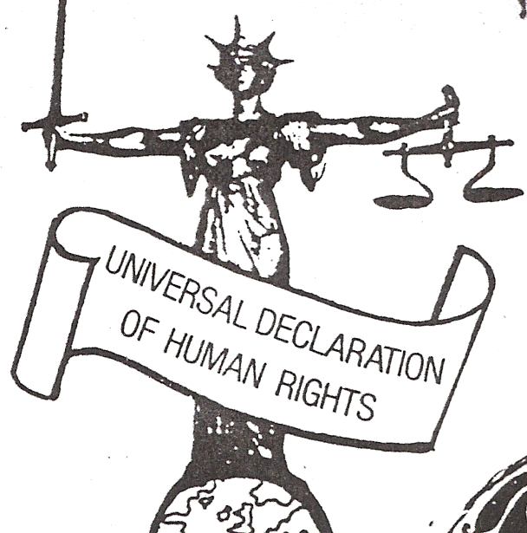
- They can ban movement, freedom of the press or any other activity.
- They can hand powers to any individuals seen fit, including foreign officials with immunity from prosecution.
- Failure to comply can mean imprisonment.
- There is no guarantee of a judicial review in the case of unreasonable use of powers.

LORD LUCAS ASKS: -
“Are we opening up our system to the equivalent of what happened in Germany in 1933, when it became possible for an extreme party legitimately to hijack a democracy and turn it into something totalitarian?”
We say an emphatic YES!

Neo-Labour Has Forfeited the Right to Govern
When a government takes this country into an illegal war, against the wishes of the people, then they forfeit the claim to lead. Labour MP’s are unpatriotic fools who slavishly follow the wishes of the largest fascist country in the world the USA.
Remember, the Government is not the country. They work for the country – the people are the country!
By taking us into war with Iraq Neo-Labour has made our country a more dangerous place to live in, behind the US we’re top of the terrorist hit list. Politicians and the Prime Minister are guilty of war crimes and must stand trial and receive a just punishment.

SILENT TAKEOVER OF OUR DEMOCRACY
At the beginning of 2006 the government brought in legislation whereby anyone can be arrested for any crime – even dropping litter. Once arrested the police take your fingerprints, photograph and DNA sample (by force if necessary) and keep them forever. And this before that person has been found guilty of any crime, whether it be dropping litter or shooting someone.
Creating a DNA database where 38% of all black men are on it as opposed to 10% of white men means that an inbuilt racism has occurred, until of course the police have our entire DNA!

Present Political Parties Have NO Answers
The three main UK political parties have no answers to the problems facing our dwindling democracy, because they are the problem!
If you are not convinced that a problem exists with the UK’s democracy, then may I refer you to Dr Vernon Coleman’s book – Living In A Fascist Country (see next page). I’m sure you will find his arguments convincing but if you don’t try writing to Dr Coleman and ask from where did he obtain all his facts. If that doesn’t convince you then you are probably a Blairite (or Blair).

The Problem Won’t Go Away on Its Own
The situation in the UK is now so serious that immediate action is required if we are committed to saving our democracy. The problem won’t sort itself out – we, the people, can only do that.
If you want to be able to tell your children or grandchildren that you took part in saving our country from a Government hell bent on control! Control! Control! then start the work now! Over the page I have some ideas on what we can do to reverse the current trend of taking our liberties from us.
For instance – a UK PRO-DEMOCRACY MOVEMENT!

The Answer – A Pro-Democracy Alliance?
Somehow a kind of robust no punches pulled kind of pro- democracy movement is urgently needed in the UK to wake people up and get them mobilised to demand better treatment from their own government. We need to remind people that it is patriotic to rid ourselves of governments that have the audacity to take away our freedoms and liberties – for whatever reason.
At all costs we must reverse the laws that have robbed us of our civil liberties, strengthen our rights and democracy so that no one can undermine the rights of the people again.

IT’S INDIVIDUALS WHO MATTER – NOT THE STATE

MP’s and their lackeys have forgotten that the individual must always come before the state, because the state is only a collection of individuals.

It has been individuals who have advanced the cause of democracy and civil liberties throughout our history, not politicians and governments. For instance, Thomas Paine, (Rights of Man), the Tolpuddle Martyrs, the Levellers etc and countless other nameless individuals who’ve died so that we can be free from oppressive governments, i.e. the men and women who died in WW2 – they believed they were fighting for freedom and democracy. Let us carry on the fight!

WINSTON CHURCHILL SUPPORTED FIGHTING FOR RIGHTS
“If you will not fight for the right,” Churchill once growled, “when you can easily win without bloodshed, if you will not fight when your victory will be sure and not so costly, you may come to the moment when you will have to fight with all the odds against you and only a precarious chance for survival. There may be a worse case. You may have to fight when there is no chance of victory, because it is better to perish than to live as slaves.”

WHAT CAN WE DO?
We must spread the word about what you have read here and elsewhere. You can (still) Protest! Protest! Protest!
Make your voice sound loud and clear – tell the Government where to get off! Write to your MP and ask them to join you in trying to retrieve our civil liberties. Write to your local press (and nationals), get on your local radio phone-ins, put up posters, and arrange talks in your town.
You can join me and help create the UK’s first

PRO-DEMOCRACY MOVEMENT!

YOU ARE THE ANSWER!
If you are serious about committing yourself to rescuing the UK from more repressive laws and getting rid of the existing ones then contact me:
Peter George Wakeham, mobile phone 07810 025818,
or email me at kittyplant@btinternet.com.

`
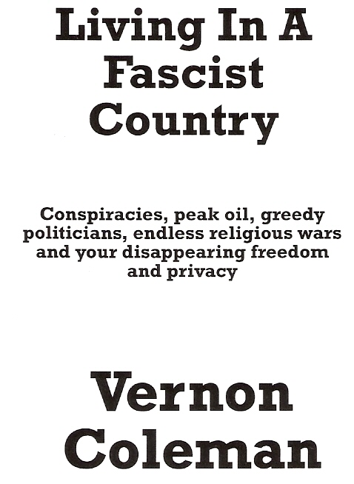

Here’s a quote from Vernon Coleman’s book:
“We can no longer rely on our Government to protect or defend us, or to do any of the things we should reasonably be able to expect it to do. We cannot expect our Ministers to do things we pay them to do. We can, however, rely on our Government and its paid servants to interfere in all areas where it has no reason to interfere and where its efforts will adversely affect our lives in all the important ways”.

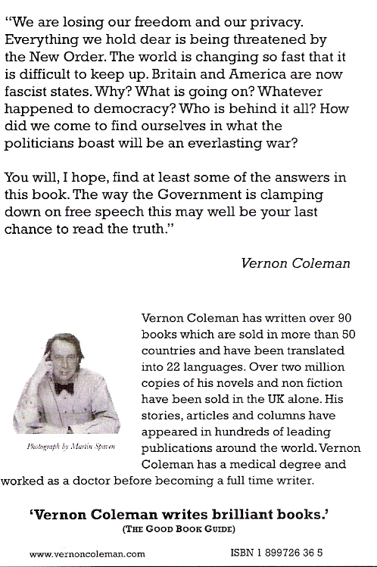

Here are Vernon’s details:
Dr Vernon Coleman, Publishing House, Trinity Place, Barnstaple, Devon, EX32 9HG.
Tel: 01271 328892 Fax: 01271 328768
Email: Info@vernoncoleman.com

