The Antifascist movement in Germany

Lecture and discussion with an activist from Germany


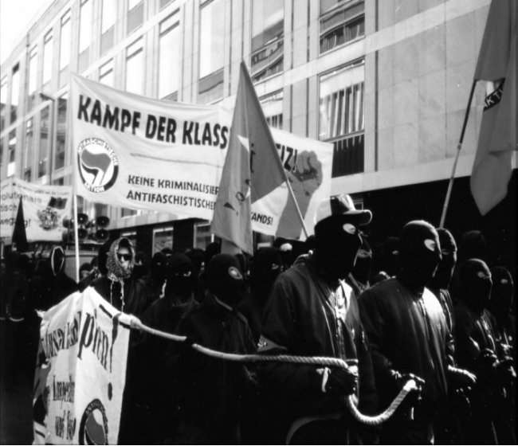



- how did the movement change over the last 20 years
- what is done against the current threat from the far right
-what can we learn from each other

Fr. 8/12/2006 6 o’clock pm
Mooreen Social Centre Sheffield
(33 Earl Street, in the old Commerce House, just off the Moor opposite Sainsburys)

for more infos see: www.mooreen.aktivix.org

