GORE-McKINNEY-FISHER- 2007
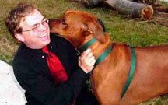
The Gore McKinney Fisher Dream Team
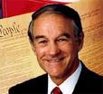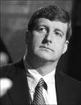
Ron Paul Mike Gravel Dennis Kucinich Tracey Marie Dorsey Al Sharpton Patrick Kennedy
Contact: AlGoreandCynthiaMcKinney@gmail.com President/Vice President
JeffFisherandAlGore@gmail.com Secretary of Peace
jjf-mlk@yahoo.fr (Code name Jante Degaul, Jeff Fisher) U.S. Attorney General

Mike Gravel To be announced
Office: 703-243-8303
Fax: 703-349-2958

Dennis Kucinich Secretary of State
info@dennis4president.com
877-41-DENNIS

Al Sharpton To be announced
106 W. 145th Street
Harlem, New York 10039
Phone: (212) 690-3070
Fax: (212) 690-3081

Tracey-Marie Dorsey Secretary of Defense holyisis@gmail.com
347-419-1675
Patrick Kennedy To be announced
249 Roosevelt Avenue, Suite 200
Pawtucket, RI 02860
Phone: (401) 729-5600
FAX: (401) 729-5608

